1104105308

四子四丙

顏君翰

電腦視覺_作業(三)

指導老師:陳昭和

備註:

Please make a program for generating Gaussian noise on an image.

Please make a program for generating salt-pepper noise on an image

Please make a program of lowpass filter for removing the above Gaussian noise and salt-pepper noise

Please make a program of median filter for removing the above Gaussian noise and salt-pepper noise.

Lowpass Filter:

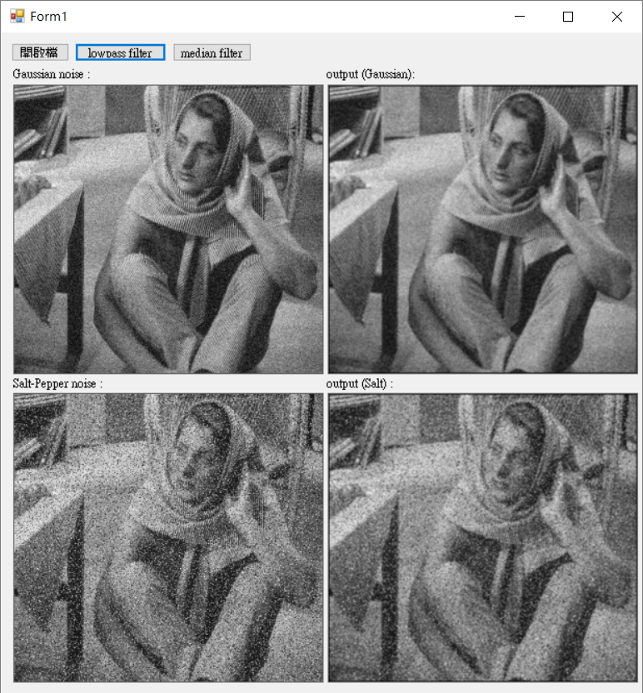

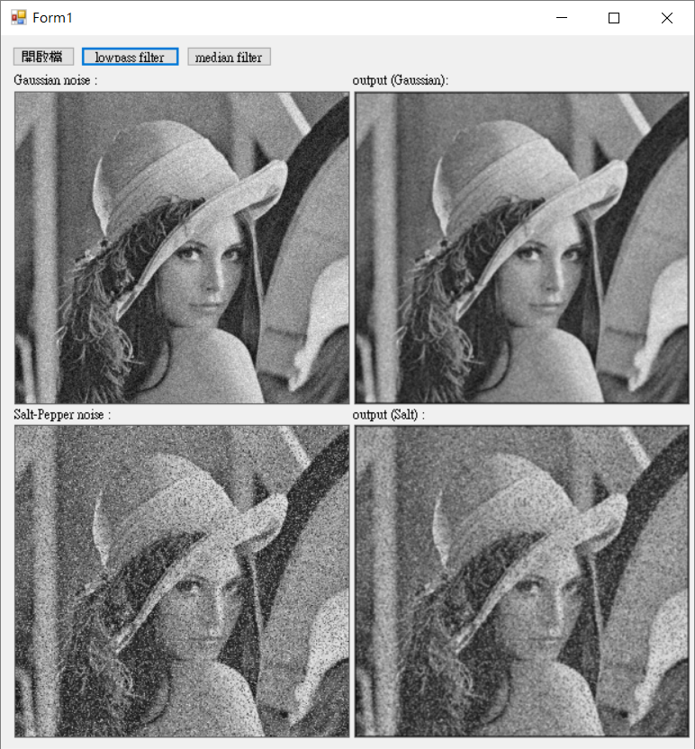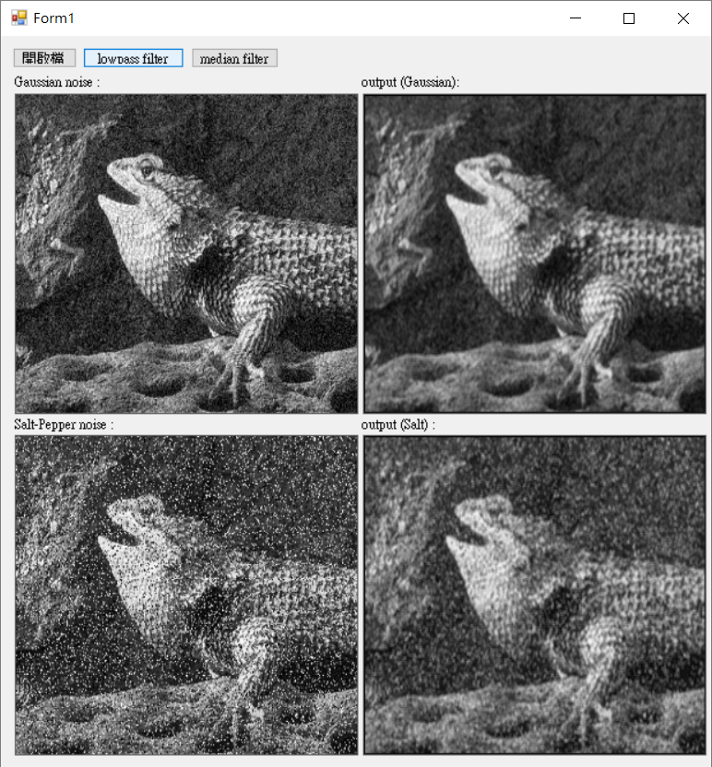

Median filter：

